The Virtues of Hugging

**After the pandemic be sure to start hugging again!**

**Why?  Because hugging is practically perfect.**   
    
·          It helps the body's immune system.   
·          It cures depression.   
·          It reduces stress.   
·          It's rejuvenating.   
·          It has no unpleasant side effects.     
·          It is all natural—contains no chemicals, artificial ingredients, pesticides, nor preservatives!

·          There are no parts to break down, no monthly payments, non-taxable, non-polluting, and best of all, **it's fully returnable!**   
        
In case you need a refresher course on how to give and receive hugs, take a look at the pictures below.







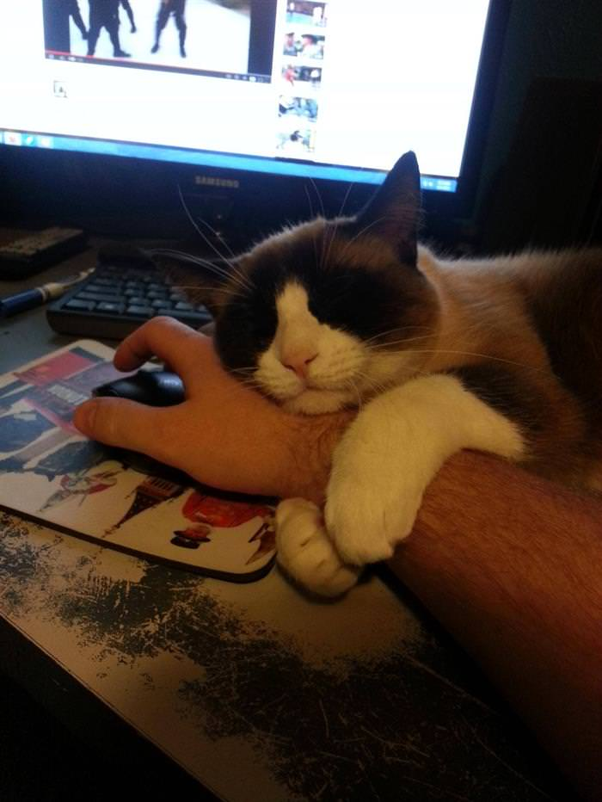





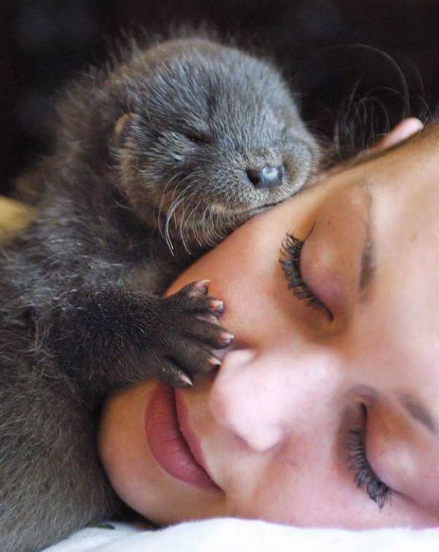





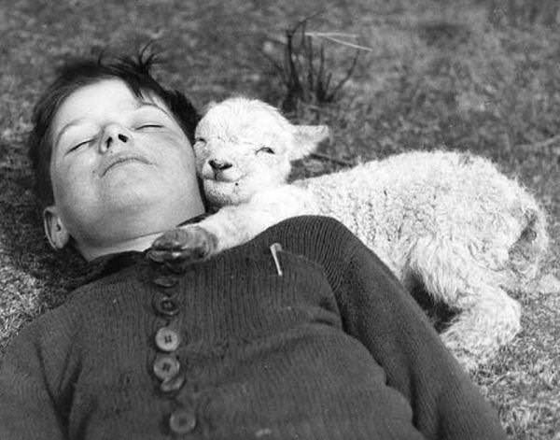





**Did you enjoy those hugs?**         
          
**Send it to the people whom you want to make**     **happy!**         
**Remember,**    **"** **A hug is the one present that's always**     **worth giving!"**