﻿
These orchids are amazing. Every one of them looks like their name. Enjoy!
Hooker’s Lips
(Psychotria Elata)
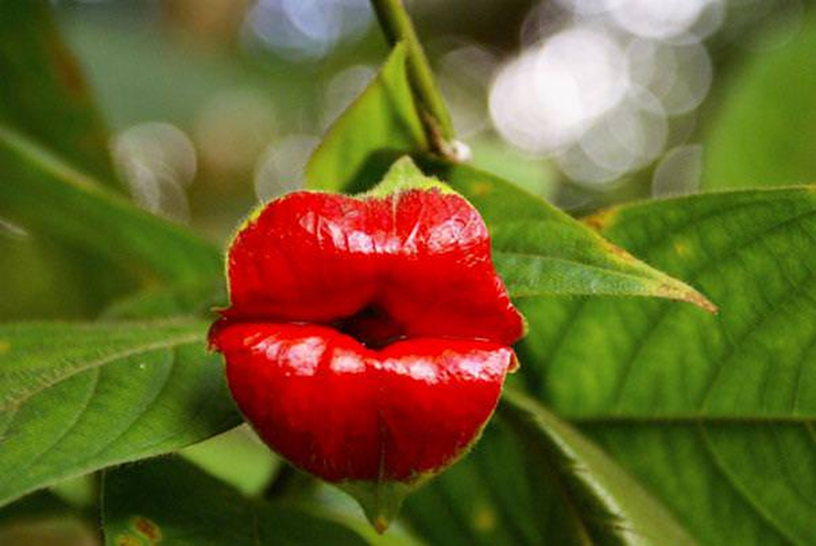
Dancing Girls
(Impatiens Bequaertii)
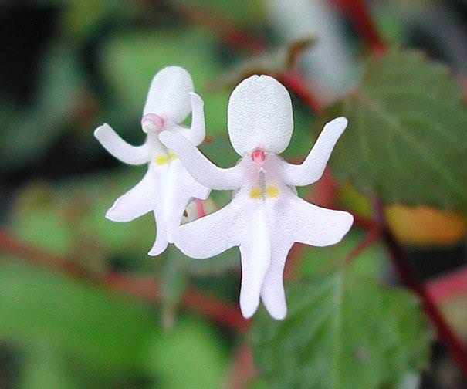

Laughing Bumble Bee Orchid
(Ophrysbbomyblifora)
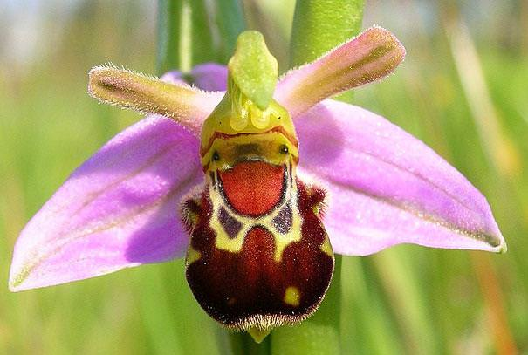

Swaddled Babies
(AnguloaUniflora)
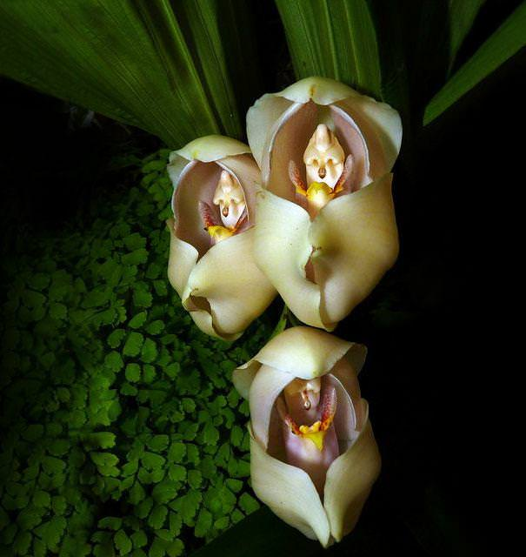
Parrot Flower
(Impatiens Psittacina)
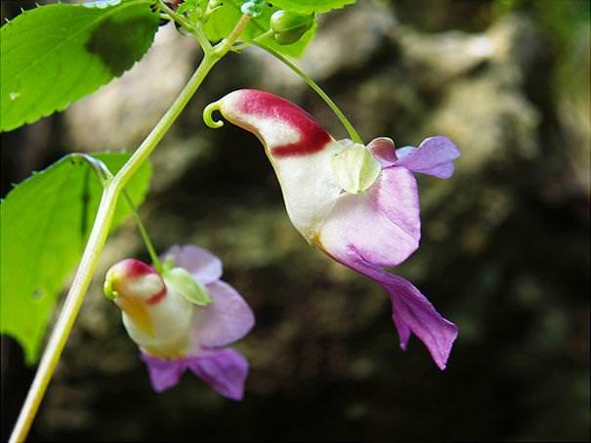

Flying Duck Orchid
(Caleana Major)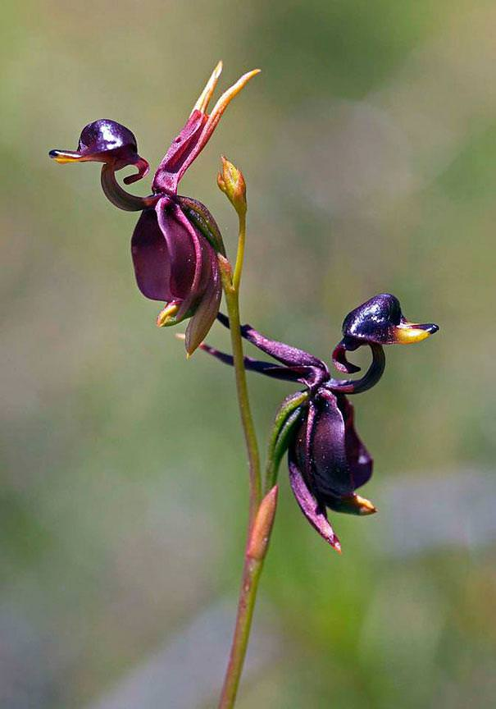
An orchid that looks remarkably
like a tiger
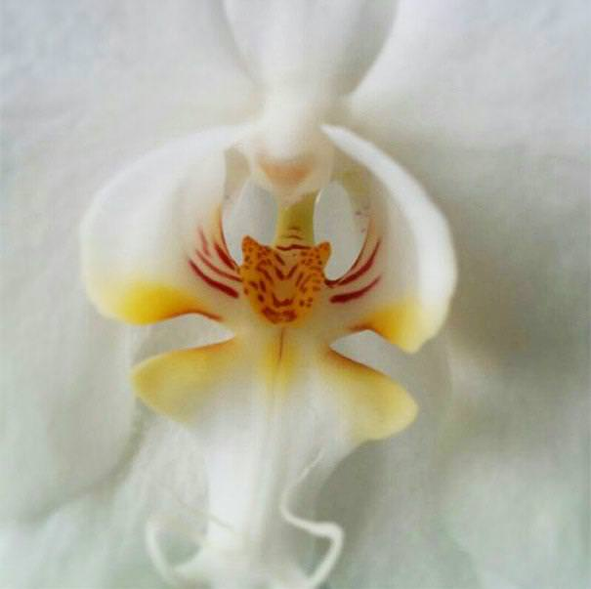
Happy Alien
(Calceolaria Uniflora)
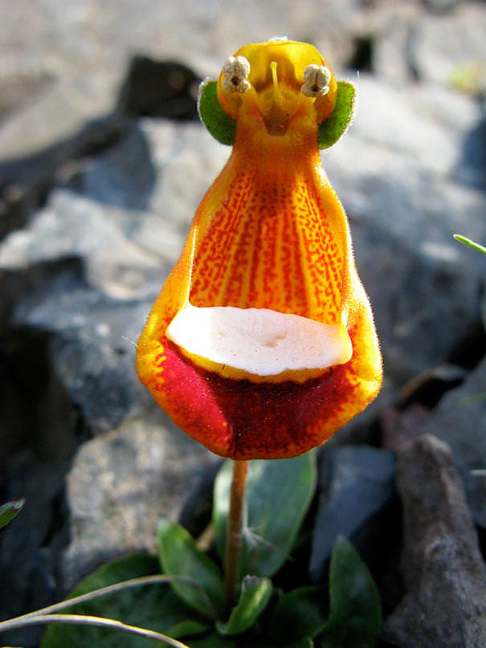
And his friends…
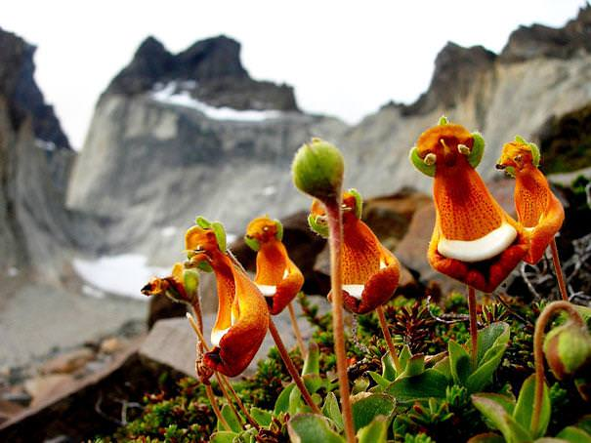

Angel Orchid
(Habenaria Grandifloriformis)
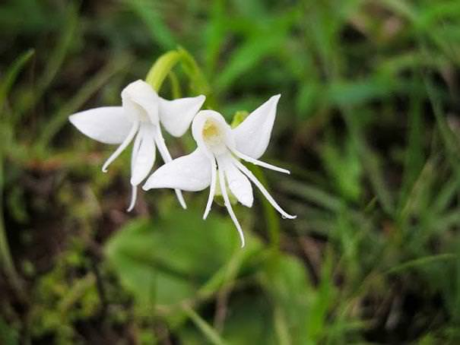

Dove Orchid Or Holy Ghost
Orchid
(Peristeria Elata)
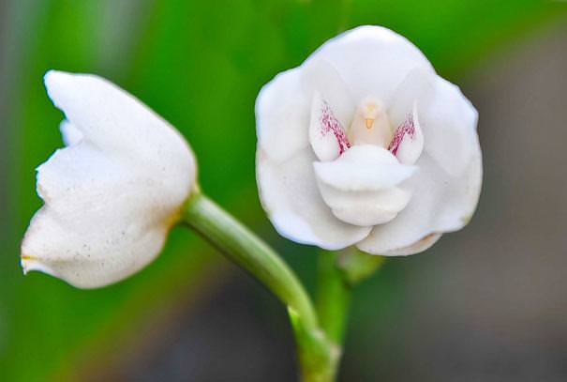

White Egret Orchid
(Habenaria Radiata)
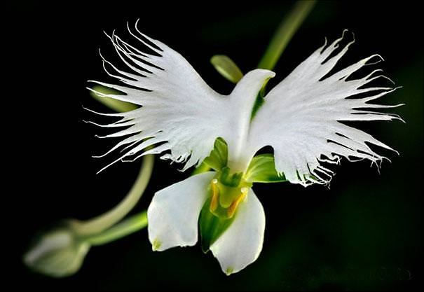

The Darth Vader
(Aristolochia Salvadorensis)
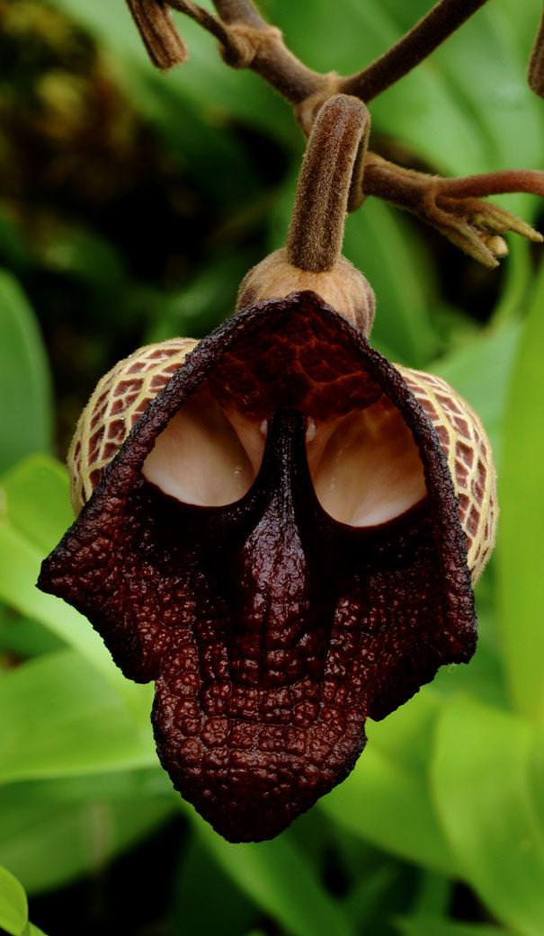

An Orchid That Looks Like A
Ballerina
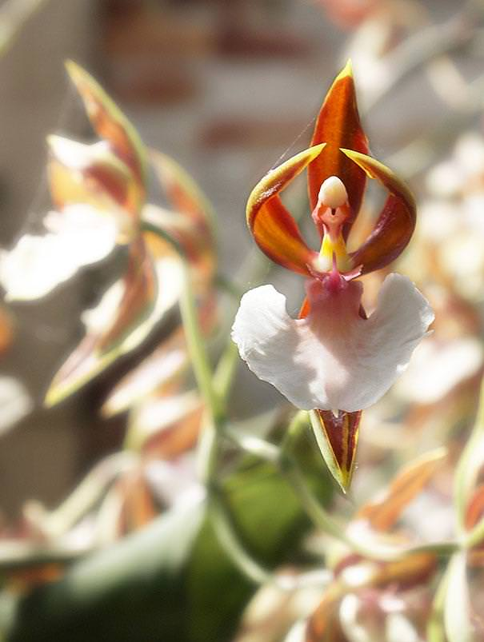
Monkey Face Orchid
(Dracula Simia)
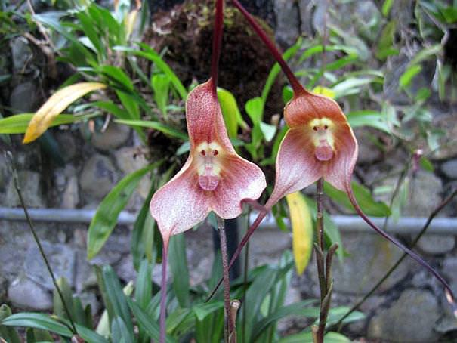

Moth Orchid
(Phalaenopsis)
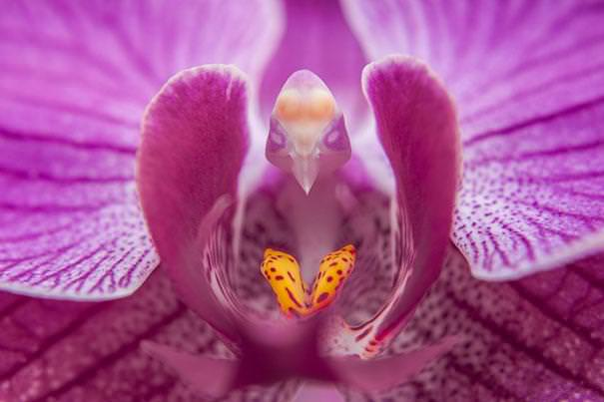
What a wonderful world!

